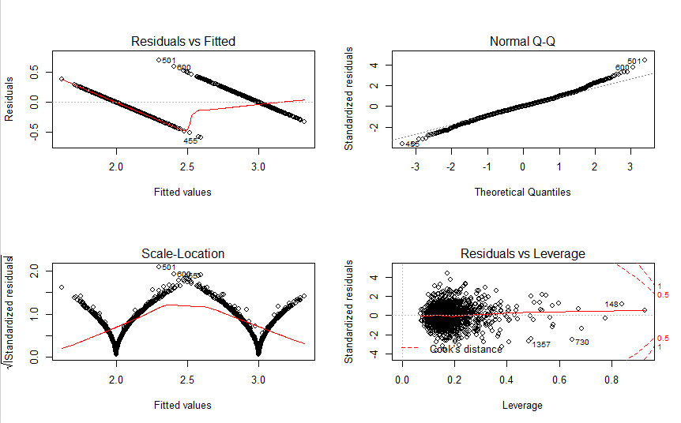

Answer:

X1_pred_train<- predict(zip_Model, zipTrain)

> X1_actual_train = zipTrain$X1

> X1_train <- sqrt(mean((X1_actual_train - X1_pred_train)^2)) #RMSE Train

> print(X1_train)

[1] 0.1575174

>

> X1_predict<- predict(zip_Model, zipTest)

> X1_actual = zipTest$X1

> X1_test <- sqrt(mean((X1_actual - X1_predict)^2)) #RMSE Test

> print(X1_test)

[1] 0.3894424

>

>

> # Part 2: K-nearest neighbor

>

> library(class)

>

> knn_1_train<-knn(train=zipTrain[,2:257],test=zipTrain[,2:257],cl = as.factor(zipTrain$X1),k=1) # Knn model for K=1

> knn_1_pred <- as.numeric(as.character(knn_1_train))

> knn_act = zipTrain$X1

> RMSE_1_train <- sqrt(mean((knn_act - knn_1_pred)^2)) #RSME

> print(RMSE_1_train)

[1] 0

>

> knn_1<-knn(train=zipTrain[,2:257],test=zipTest[,2:257],cl = as.factor(zipTrain$X1),k=1) # Knn model for K=1

> knn_1_predict <- as.numeric(as.character(knn_1))

> knn_actual = zipTest$X1

> RMSE_1_test <- sqrt(mean((knn_actual - knn_1_predict)^2)) #RSME

> print(RMSE_1_test)

[1] 0.1572427

>

> knn_3_train<-knn(train=zipTrain[,2:257],test=zipTrain[,2:257],cl = as.factor(zipTrain$X1),k=3) # Knn model for K=3

> knn_3_pred <- as.numeric(as.character(knn_3_train))

> RMSE_3_train <- sqrt(mean((knn_act - knn_3_pred)^2)) #RSME

> print(RMSE_3_train)

[1] 0.07099012

>

> knn_3<-knn(train=zipTrain[,2:257],test=zipTest[,2:257],cl = as.factor(zipTrain$X1),k=3) # Knn model for K=3

> knn_3_predict <- as.numeric(as.character(knn_3))

> RMSE_3_test<-sqrt(mean((knn_actual - knn_3_predict)^2)) #RSME

> print(RMSE_3_test)

[1] 0.1738384

>

> knn_5_train<-knn(train=zipTrain[,2:257],test=zipTrain[,2:257],cl = as.factor(zipTrain$X1),k=5) # Knn model for K=5

> knn_5_pred <- as.numeric(as.character(knn_5_train))

> RMSE_5_train <- sqrt(mean((knn_act - knn_5_pred)^2)) #RSME

> print(RMSE_5_train)

[1] 0.07589163

>

> knn_5<-knn(train=zipTrain[,2:257],test=zipTest[,2:257],cl = as.factor(zipTrain$X1),k=5) # Knn model for K=5

> knn_5_predict <- as.numeric(as.character(knn_5))

> RMSE_5_test<-sqrt(mean((knn_actual - knn_5_predict)^2)) #RSME

> print(RMSE_5_test)

[1] 0.1738384

>

> knn_7_train<-knn(train=zipTrain[,2:257],test=zipTrain[,2:257],cl = as.factor(zipTrain$X1),k=7) # Knn model for K=7

> knn_7_pred <- as.numeric(as.character(knn_7_train))

> RMSE_7_train <- sqrt(mean((knn_act - knn_7_pred)^2)) #RSME

> print(RMSE_7_train)

[1] 0.08049523

>

> knn_7<-knn(train=zipTrain[,2:257],test=zipTest[,2:257],cl = as.factor(zipTrain$X1),k=7) # Knn model for K=7

> knn_7_predict <- as.numeric(as.character(knn_7))

> RMSE_7_test<-sqrt(mean((knn_actual - knn_7_predict)^2)) #RSME

> print(RMSE_7_test)

[1] 0.1815683

>

> knn_15_train<-knn(train=zipTrain[,2:257],test=zipTrain[,2:257],cl = as.factor(zipTrain$X1),k=15) # Knn model for K=15

> knn_15_pred <- as.numeric(as.character(knn_15_train))

> RMSE_15_train <- sqrt(mean((knn_act - knn_15_pred)^2)) #RSME

> print(RMSE_15_train)

[1] 0.09674322

>

> knn_15<-knn(train=zipTrain[,2:257],test=zipTest[,2:257],cl = as.factor(zipTrain$X1),k=15) # Knn model for K=15

> knn_15_predict <- as.numeric(as.character(knn_15))

> RMSE_15_test<-sqrt(mean((knn_actual - knn_15_predict)^2)) #RSME

> print(RMSE_15_test)

[1] 0.1961161